Chapter 9 Properties and reactions of organic compounds

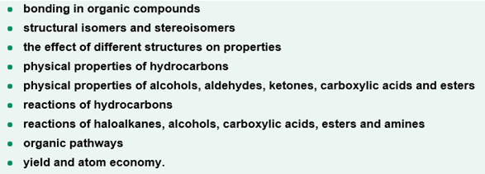

Test 9
Section A (20 marks)
1. The weakest type of intermolecular bonding involves
A. hydrogen bonding
B. dispersion forces
C. ion-dipole bonding
D. dipole-dipole bonding

2. The type(s) of intermolecular forces existing between molecules of ethyl ethanoate are
A. dispersion forces only
B. dispersion forces and dipole-dipole bonding
C. dipole-dipole and hydrogen bonding
D. dispersion forces and hydrogen bonding

3. The chiral carbon in the following molecule is
H Cl H H
H
H C C C C N
H
H O H H H
a b c d
A. a
B. b
C. c
D. d

4. Which molecule would be expected to have the highest boiling point?
A. ethanoic acid
B. ethanol
C. ethanal
D. ethane
5. Which molecule would be expected to have the lowest flash point?
A. ethanoic acid
B. ethanol
C. ethanal
D. ethane

6. The following reaction is an example of
CH₃Cl + NaOH CH₃OH + NaCl
A. an addition reaction
B. a condensation reaction
C. a substitution reaction
D. an oxidation reaction

7. The reaction of acidified Cr₂O₇²⁻ with propan-2-ol will produce
A. propanal
B. propanoic acid
C. propanone
D. 2-propyl propanate

8. The monomer that would be used to form the polymer below would be

CH₂CH₃ Cl CH₂CH₃ Cl CH₂CH₃ Cl CH₂CH₃ Cl

C C C C

C C C C

CH₃ Cl CH₃ Cl CH₃ Cl CH₃ Cl

A.
CH₂CH₃ Cl
C = C
H₃C Cl
B.
CH₂CH₃ CH₃
C = C
Cl Cl

C.
CH₂CH₃ Cl
C - C
H₃C Cl

D.
CH₂CH₃ CH₃
C - C
Cl Cl
9. Aspirin (acetylsalicylic acid) (M = 180 gmol⁻¹) can be formed by reacting salicylic acid (M = 138 gmol⁻¹) with acetic anhydride (M = 102 gmol⁻¹) as shown in the equation below
salicylic acid + acetic anhydride acetylsalicylic acid + ethanoic acid
When Sally carried out this reaction using 10.0 g of salicylic acid and 10.0 g of acetic anhydride she isolated 10.2 g of aspirin. The percentage yield obtained by Sally was
A. 56.8 %
B. 72.5 %
C. 78.2 %
D. 98.0 %

10. One way of producing ethanol from ethene is by the using the following reaction pathway:

ethene ethane chloroethane ethanol

If each of the three steps had a percentage yield of 80 %, the overage percentage yield of ethanol would be closest to
A. 50 %
B. 60 %
C. 70 %
D. 80 %

Section B (30 marks)
1. Complete the table below by placing a tick in the box corresponding to the intermolecular force(s) that exists between the molecules of the six compounds listed below.

Compound | Type of intermolecular force of attraction
 | Dispersion force | Dipole-dipole bonding | Hydrogen bonding
2-methylbutane
propan-2-ol
ethanamine
dichloromethane
ethanoic acid
methyl propanoate
[6 marks]

2. Draw and label the cis- and trans- isomers of but-2-ene.
[2 marks]

3. Describe the type of isomerism present in each of the following pairs of compounds.
(a)
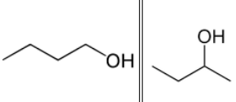

(b)
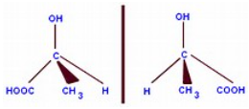

(c)
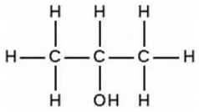
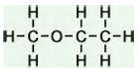

(d)
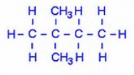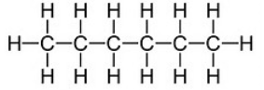

[4 marks]
4. By referring to the weak bonding that exists between the molecules of the following compounds, explain the differences in their boiling points.
Compound | Molecular mass | Boiling point (ºC)
chloromethane | 50.5 | - 24
ethanol | 46.0 | 78
propane | 44.0 | - 42
methanioc acid | 46.0 | 101
[4 marks]

5. Write balanced chemical equations, using semi-structural formulas, for the reactions between
(a) propene and chlorine
(b) 2-chlorobutane and sodium hydroxide
(c) ethane and chlorine in the presence of UV light (assume only one H atom is substituted)
(d) but-2-ene and water using a phosphoric acid catalyst
(e) ethene molecules using a nickel catalyst
(f) propan-2-ol and ammonia using an Al₂O₃ catalyst and elevated temperature.
(g) ethanol and an acidified potassium dichromate solution
* give two possible products
* just list the products for these two reactions (balanced chemical equations are not required)
(h) propanoic acid and propan-1-ol using a concentrated sulfuric acid catalyst
[9 marks]

6. Complete the following reaction scheme by naming compounds X and Y and reagents A, B and C
propene

X
HCl

A
propan-1-ol

B
Y

C
ethyl propanoate

[5 marks]

Solutions for test 9
Section A (10 x 2 =20 marks)
1. B
2. B
3. B
4. A
5. D
6. C
7. C
8. B
9. C
10. A

Section B (30 marks) [marks are denoted by square brackets]
1. [1] for each correct row
Compound | Type of intermolecular force of attraction
 | Dispersion force | Dipole-dipole bonding | Hydrogen bonding
2-methylbutane | √
propan-2-ol | √ |  | √
ethanamine | √ |  | √
dichloromethane | √ | √
ethanoic acid | √ |  | √
methyl propanoate | √ | √
[6x1]
2. [1] for each correctly labelled structure
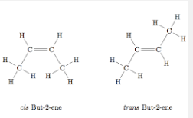
<make the names under the structures cis-but-2-ene and trans-but-2-ene > [2]

3(a) They are positional isomers (a type of structural isomer)
(b) They are optical isomers (a type of stereoisomer isomer)
(c) They are functional isomers (a type of structural isomer)
(d) They are chain isomers (a type of structural isomer) [4x1]

4.
Compound | Molecular mass | Boiling point (ºC) | Intermolecular forces between molecules
 |  |  | dispersion | dipole-dipole | hydrogen
chloromethane | 50.5 | - 24 | √ | √
ethanol | 46.0 | 78 | √ |  | √
propane | 44.0 | - 42 | √
methanioc acid | 46.0 | 101 | √ |  | √

- All four compounds have similar masses and would therefore have similar dispersion forces between molecules. [1]
- Propane has only dispersion forces between its molecules [1]
- Chloromethane also has dipole-dipole forces of attraction between its molecules [1]
- Both ethanol and methanoic acid also have hydrogen bonds between their respective molecules, but the hydrogen bonds are stronger between methanoic acid molecules because of the increased polarity in the O – H (hydroxyl) group caused by the presence of the C=O (carbonyl) group [1]

5(a) CH₂CHCH₃ + Cl₂ CH₂ClCHClCH₃
(b) CH₃CHClCH₂CH₃ + NaOH CH₃CH(OH)CH₂CH₃ + NaCl
(c) CH₃CH₃ + Cl₂ UV CH₃CH₂Cl + HCl
(d) CH₃CHCHCH₃ + H₂O H₃PO₄ CH₃CH(OH)CH₂CH₃
(e) n(CH₂CH₂) Ni - ( CH₂CH₂)_{n} -
(f) CH₃CH(OH)CH₃ + NH₃ Al₂O₃ CH₃CH(NH₂)CH₃ + H₂O
(g) CH₃CH₂OH Cr₂O₇²⁻ / H⁺ CH₃CHO
CH₃CH₂OH Cr₂O₇²⁻ / H⁺ CH₃COOH
(h) CH₃CH₂COOH + CH₃CH₂CH₂OH H₂SO₄(l) CH₃CH₂COOCH₂CH₂CH₃ + H₂O [9 x 1]

6. X = 1-chloropropane
A = sodium hydroxide
B = acidified dichromate ions
Y = propanoic acid
C = ethanol (in the presence of a few drops of concentrated sulfuric acid)

